**Chapter 1**

**Parametric Equations and Polar Coordinates**

**1.5 Conic Sections**

**Section Exercises**

**For the following exercises, determine the equation of the parabola using the information given.**

1. Focus  and directrix 

Answer: 

1. Focus and directrix 

Answer: 

1. Focus and directrix 

Answer: 

1. Focus  and directrix 

Answer: 

1. Focus and directrix 

Answer: 

1. Focus and directrix 

Answer: 

1. Focus and directrix 

Answer: 

1. Focus and directrix 

Answer: 

**For the following exercises, determine the equation of the ellipse using the information given.**

1. Endpoints of major axis at  and foci located at 

Answer: 

1. Endpoints of major axis at and foci located at 

Answer: 

1. Endpoints of minor axis at and foci located at 

Answer: 

1. Endpoints of major axis at and foci located at 

Answer: 

1. Endpoints of major axis at and foci located at 

Answer: 

1. Endpoints of major axis at and foci located at 

Answer: 

1. Foci located at and eccentricity of 

Answer: 

1. Foci located atand eccentricity of 

Answer: 

**For the following exercises, determine the equation of the hyperbola using the information given.**

1. Vertices located at  and foci located at 

Answer: 

1. Vertices located at  and foci located at 

Answer: 

1. Endpoints of the conjugate axis located at  and foci located 

Answer: 

1. Vertices located at  and focus located at 

Answer: 

1. Vertices located at  and focus located at 

Answer: 

1. Endpoints of the conjugate axis located at  and focus located at 

Answer: 

1. Foci located at  and eccentricity of 3

Answer: 

1. and eccentricity of 2.5

Answer: 

**For the following exercises, consider the following polar equations of conics. Determine the eccentricity and identify the conic.**

1. 

Answer:  parabola

1. 

Answer:  ellipse

1. 

Answer:  ellipse

1. 

Answer:  hyperbola

1. 

Answer:  hyperbola

1. 

Answer:  ellipse

**For the following exercises, find a polar equation of the conic with focus at the origin and eccentricity and directrix as given.**

1. 

Answer: 

1. 

Answer: 

1. 

Answer: 

1. 

Answer: 

**For the following exercises, sketch the graph of each conic.**

1. 

Answer:

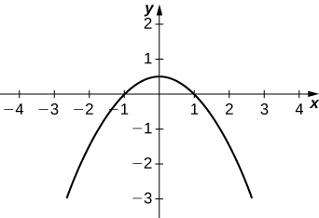

1. 

Answer:

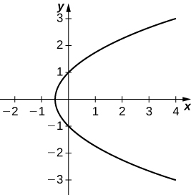

1. 

Answer:

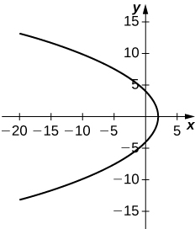

1. 

Answer:

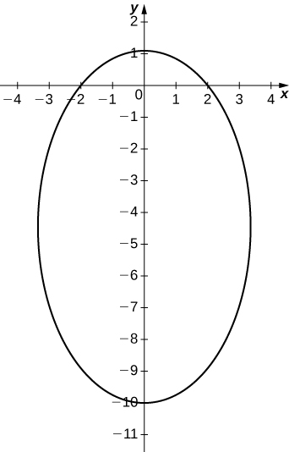

1. 

Answer:

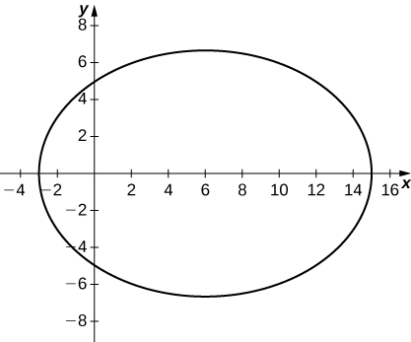

1. 

Answer:

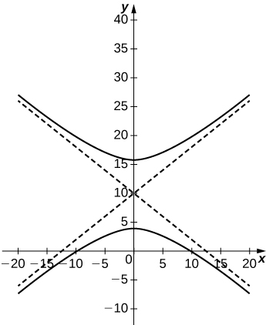

1. 

Answer:

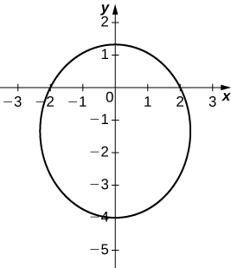

1. 

Answer:

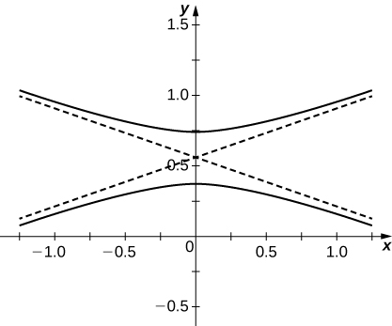

1. 

Answer:

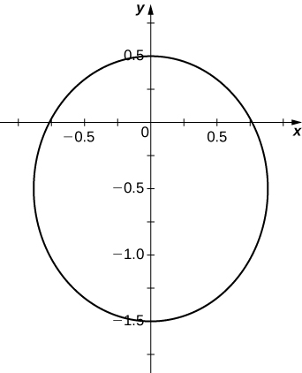

1. 

Answer:

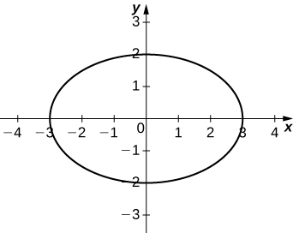

1. 

Answer:

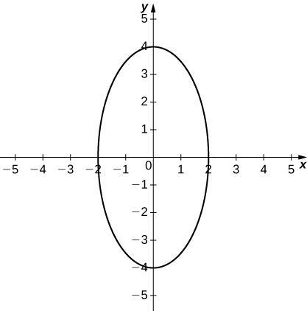

1. 

Answer:

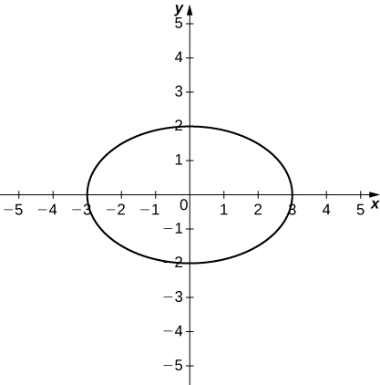

1. 

Answer:

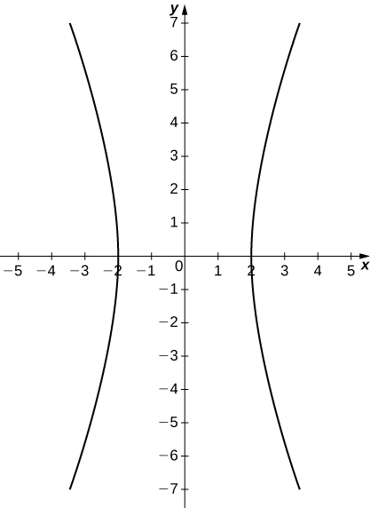

1. 

Answer:

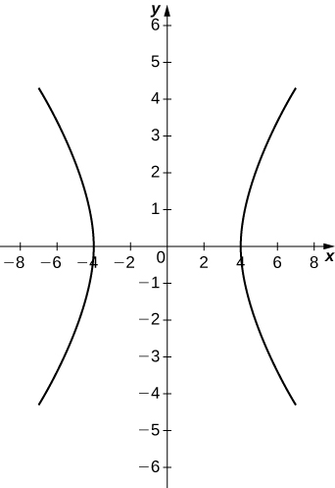

1. 

Answer:

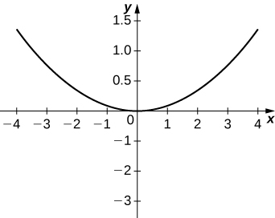

1. 

Answer:

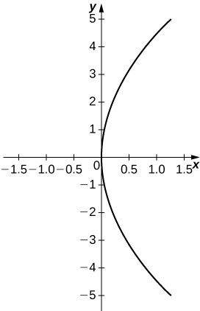

1. 

Answer:

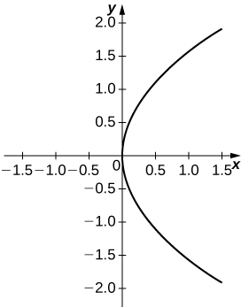

**For the following equations, determine which of the conic sections is described.**

1. 

Answer: Hyperbola

1. 

Answer: Hyperbola

1. 

Answer: Parabola

1. 

Answer: Ellipse

1. 

Answer: Ellipse

1. 

Answer: Ellipse

1. The mirror in an automobile headlight has a parabolic cross section, with the lightbulb at the focus. On a schematic, the equation of the parabola is given as  At what coordinates should you place the lightbulb?

Answer: 

1. A satellite dish is shaped like a paraboloid of revolution. The receiver is to be located at the focus. If the dish is 12 feet across at its opening and 4 feet deep at its center, where should the receiver be placed?

Answer: At the point 2.25 feet above the vertex.

1. Consider the satellite dish of the preceding problem. If the dish is 8 feet across at the opening and 2 feet deep, where should we place the receiver?

Answer: At the point 2 feet above the vertex.

1. A searchlight is shaped like a paraboloid of revolution. A light source is located 1 foot from the base along the axis of symmetry. If the opening of the searchlight is 3 feet across, find the depth.

Answer: 0.5625 feet

1. Whispering galleries are rooms designed with elliptical ceilings. A person standing at one focus can whisper and be heard by a person standing at the other focus because all the sound waves that reach the ceiling are reflected to the other person. If a whispering gallery has a length of 120 feet and the foci are located 30 feet from the center, find the height of the ceiling at the center.

Answer: Approximately 51.96 feet

1. A person is standing 8 feet from the nearest wall in a whispering gallery. If that person is at one focus and the other focus is 80 feet away, what is the length and the height at the center of the gallery?

Answer: Length is 96 feet and height is approximately 26.53 feet.

**For the following exercises, determine the polar equation form of the orbit given the length of the major axis and eccentricity for the orbits of the comets or planets. Distance is given in astronomical units (AU).**

1. Halley’s Comet: length of major axis = 35.88, eccentricity = 0.967

Answer: 

1. Hale-Bopp Comet: length of major axis = 525.91, eccentricity = 0.995

Answer: 

1. Mars: length of major axis = 3.049, eccentricity = 0.0934

Answer: 

1. Jupiter: length of major axis = 10.408, eccentricity = 0.0484

Answer: 

**Chapter Review Exercises**

***True or False*. Justify your answer with a proof or a counterexample.**

1. The rectangular coordinates of the point  are .

Answer: False. They are 

1. The equations   represent a hyperbola.

Answer: True.

1. The arc length of the spiral given by for  is 

Answer: False.

1. Given  and  if  then  where C is a constant.

Answer: False. Imagine  

**For the following exercises, sketch the parametric curve and eliminate the parameter to find the Cartesian equation of the curve.**

1.   

Answer:

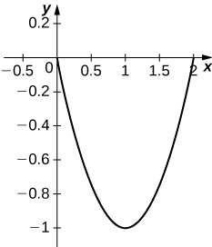



1.   

Answer:

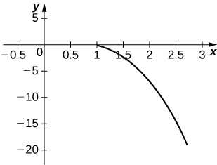



1.   

Answer:

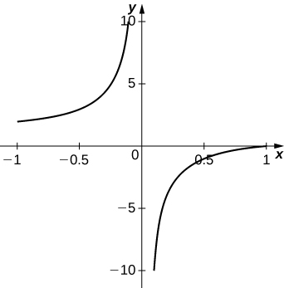



1.   

Answer:

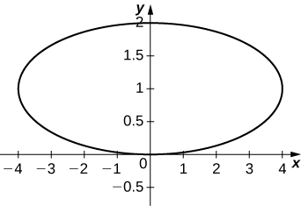



**For the following exercises, sketch the polar curve and determine what type of symmetry exists, if any.**

1. 

Answer:

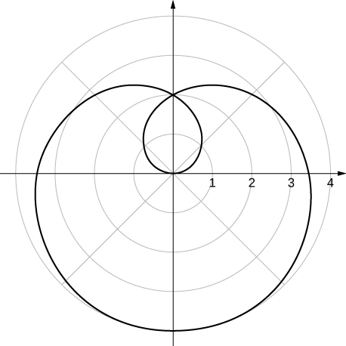

Symmetric about polar axis, pole, and 

1. 

Answer:

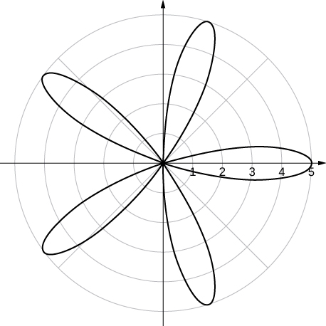

Symmetric about polar axis

**For the following exercises, find the polar equation for the curve given as a Cartesian equation.**

1. 

Answer: 

1. 

Answer: 

**For the following exercises, find the equation of the tangent line to the given curve. Graph both the function and its tangent line.**

1.   

Answer: 

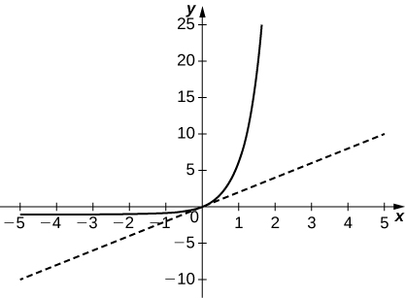

1.  

Answer: 

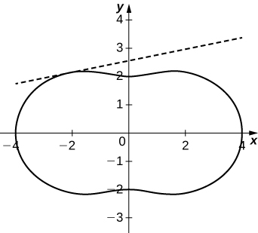

1. Find   and of  

Answer:   

**For the following exercises, find the area of the region.**

1.   

Answer: 

1.  in the first quadrant

Answer: 

**For the following exercises, find the arc length of the curve over the given interval.**

1.   

Answer: 

1.   Check your answer by geometry.

Answer: 

**For the following exercises, find the Cartesian equation describing the given shapes.**

1. A parabola with focus  and directrix 

Answer: 

1. An ellipse with a major axis length of 10 and foci at  and 

Answer: 

1. A hyperbola with vertices at  and  and foci at  and 

Answer: 

**For the following exercises, determine the eccentricity and identify the conic. Sketch the conic.**

1. 

Answer: , hyperbola

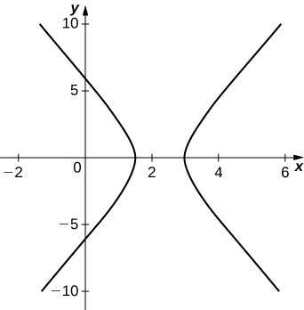

1. 

Answer: , ellipse

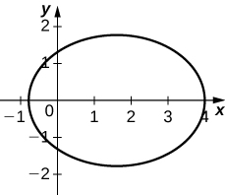

1. 

Answer: , parabola

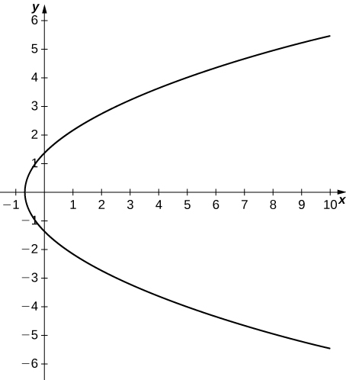

1. Determine the Cartesian equation describing the orbit of Pluto, the most eccentric orbit around the Sun. The length of the major axis is 39.26 AU and minor axis is 38.07 AU. What is the eccentricity?

Answer:  

1. The C/1980 E1 comet was observed in 1980. Given an eccentricity of 1.057 and a perihelion (point of closest approach to the Sun) of 3.364 AU, find the Cartesian equations describing the comet’s trajectory. Are we guaranteed to see this comet again? (*Hint*: Consider the Sun at point 

Answer:  no

This file is copyright 2016, Rice University. All Rights Reserved.